Project Development Phase Delivery of Sprint-1

|  |  |
| --- | --- |
| **Team ID** | **PNT2022TMID38670** |
| **Project Name** | **Retail Store Stock Inventory Analytics** |

**Project Development Phase: Sprint-1:**

1.Fetch Data from external API (Kaggle API)

2. IBM DB2 service creation and DB2connectivity with cognos

3.Data Collection

4.Data Preparation

**Sprint-2:**

Data Exploration

**Sprint-3:**

Dashboard Creation

**Sprint-4:**

1.Report Creation

2.Story Creation

DATA COLLECTION :

Download the Dataset

Dataset link - https://drive.google.com/drive/folders/1kiL- 5CHJmQvbk9VyFsuUs-myAupBZGNy

**1.FETCH DATA FROM EXTERNAL API (KAGGLE API)**

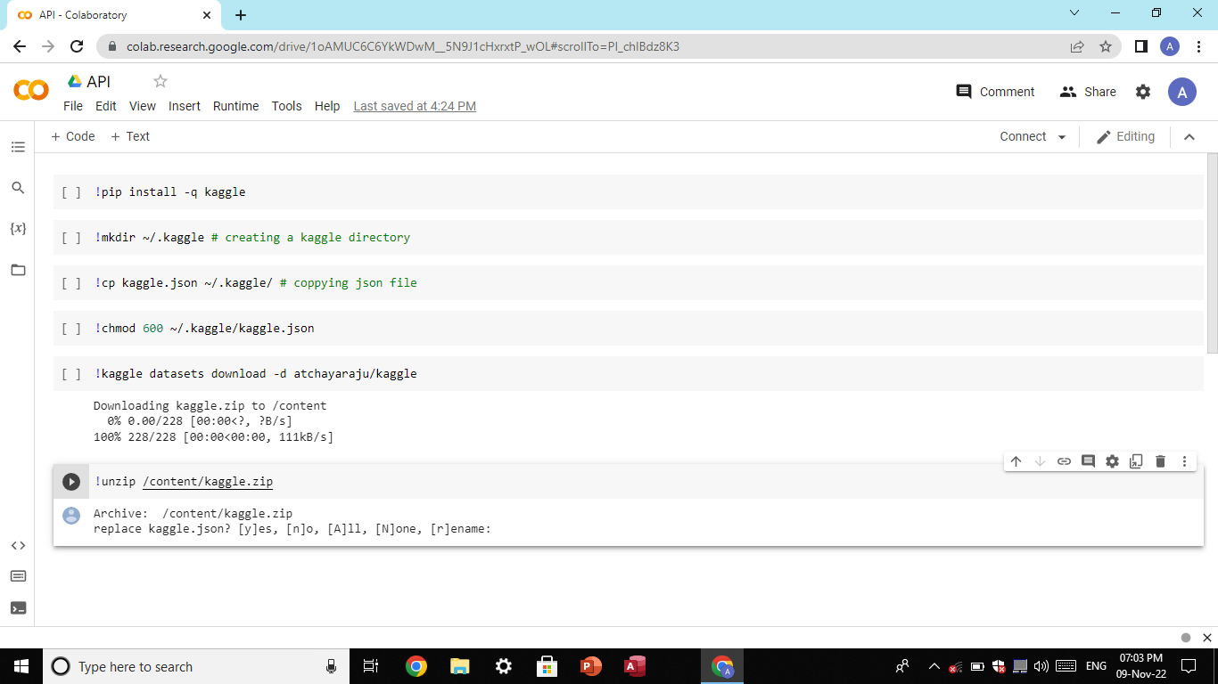

**2.IBM DB2 SERVICE CREATION AND DB2 CONNECTIVITY WITH COGNOS**

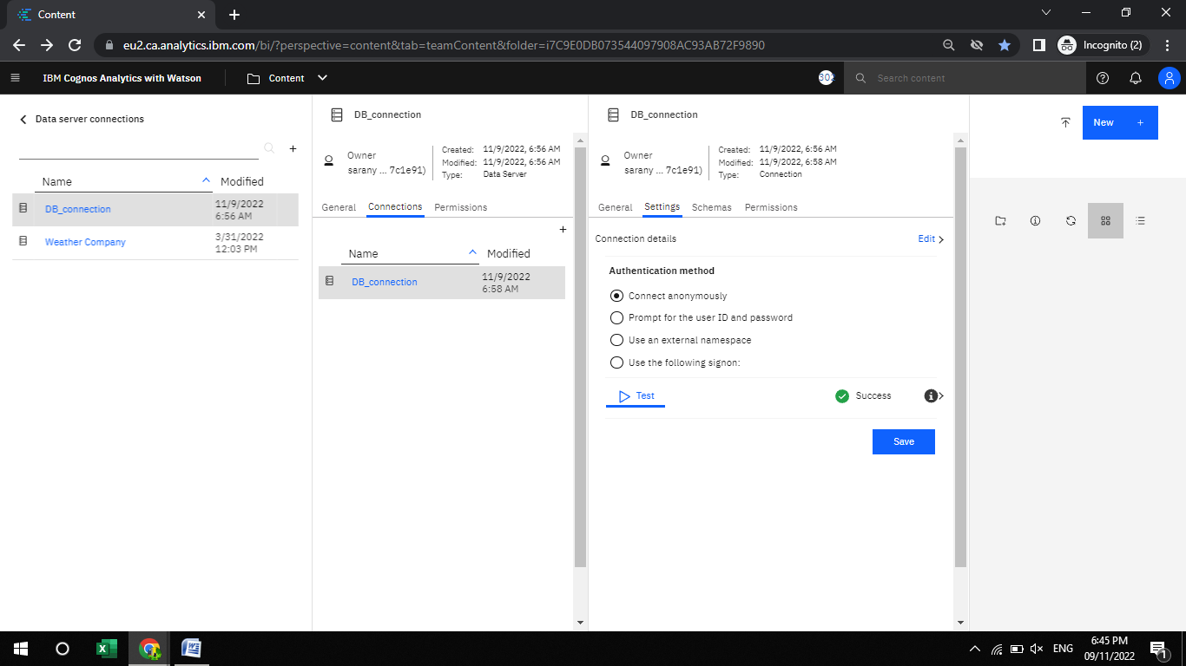

LOAD THE DATASET:

Tool used – IBM Cognos

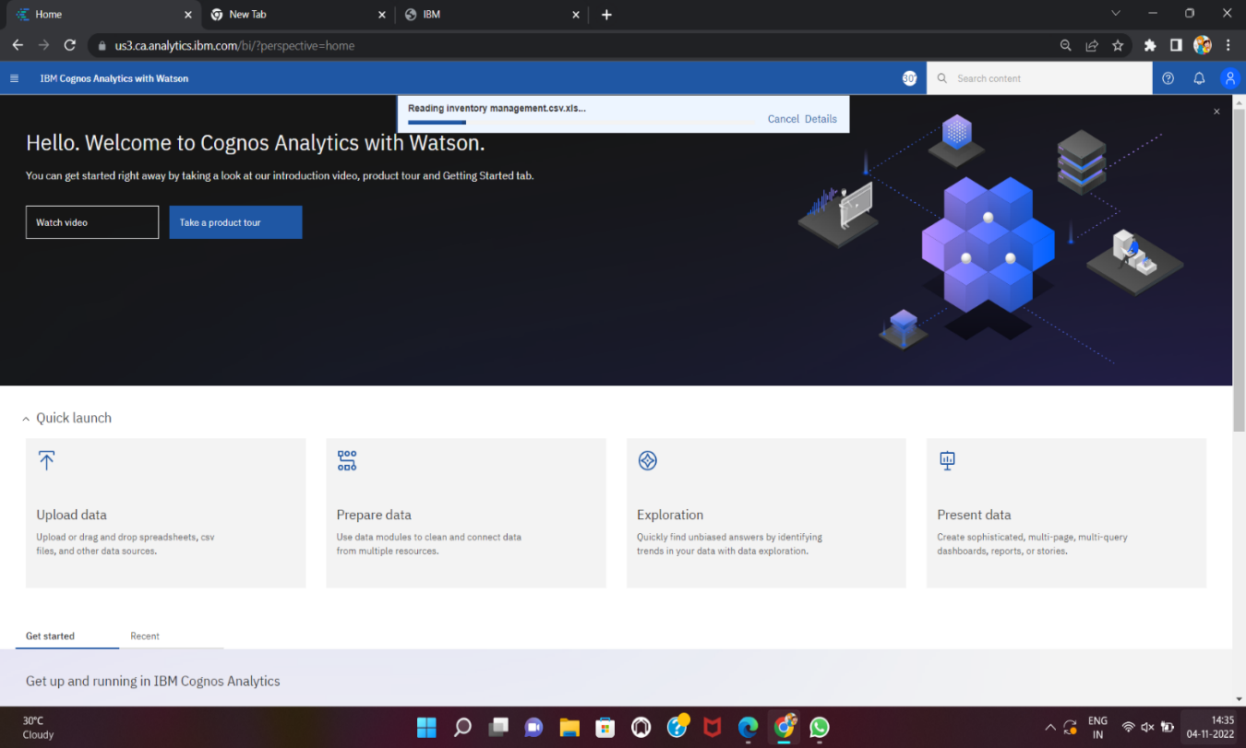

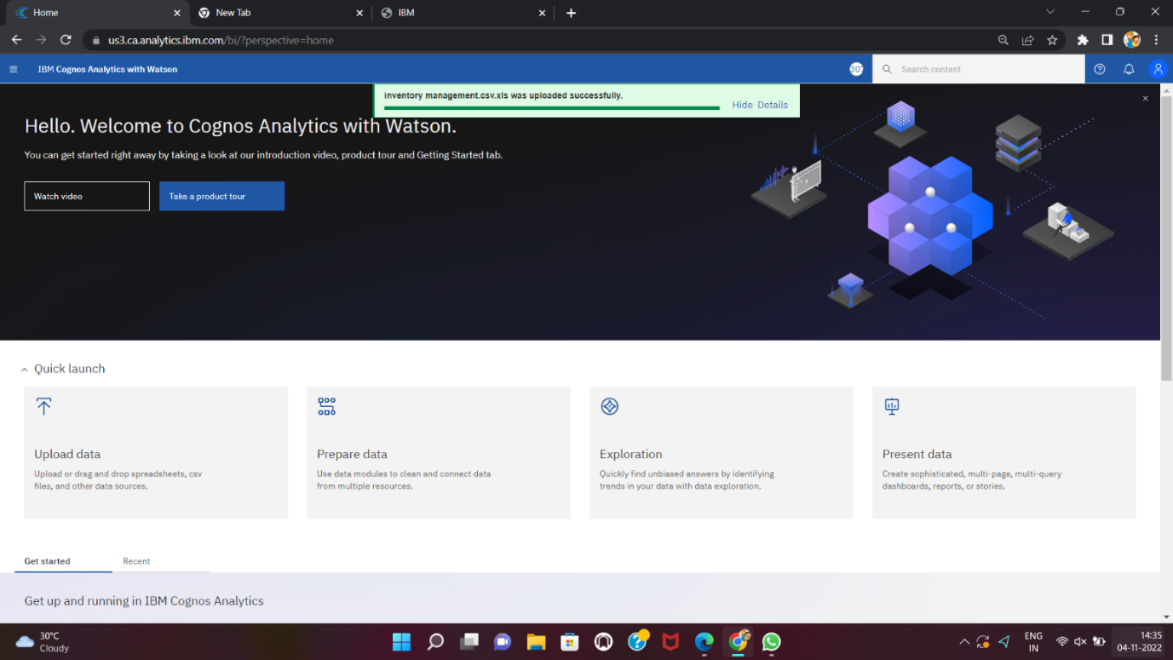

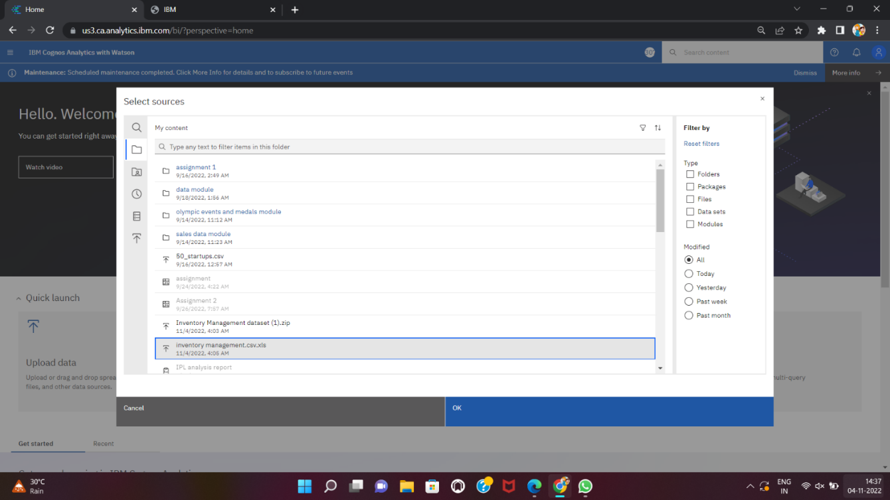

**MONTH DATA CALCULATION:**

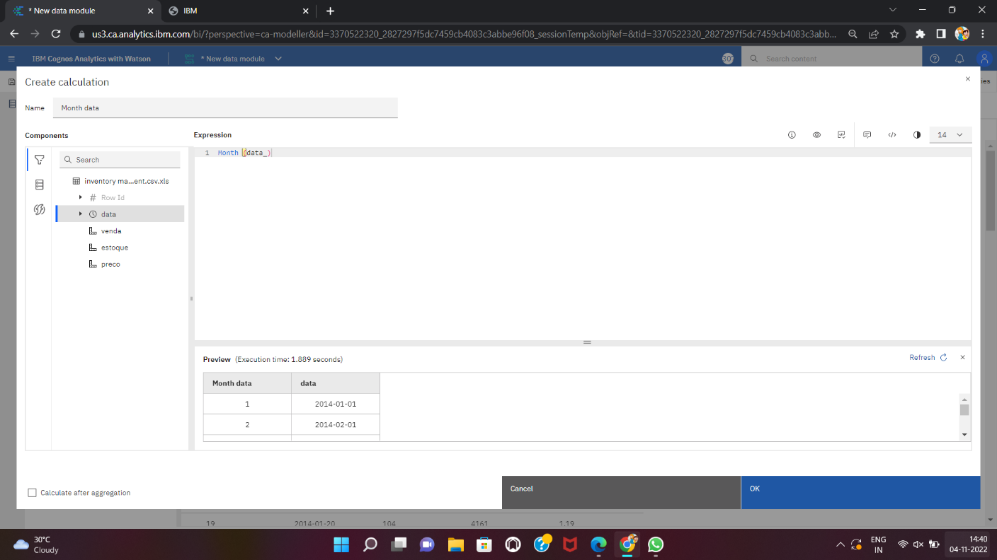

**SALES CALCULATION:**

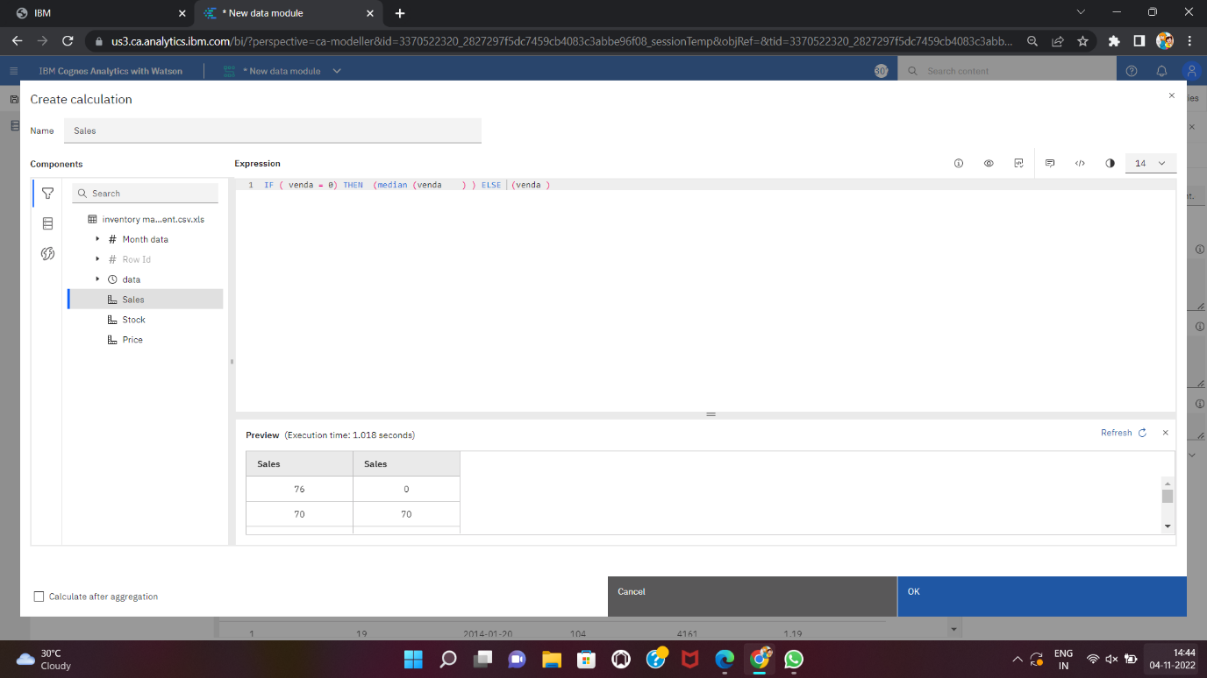

STOCK CALCULATION:

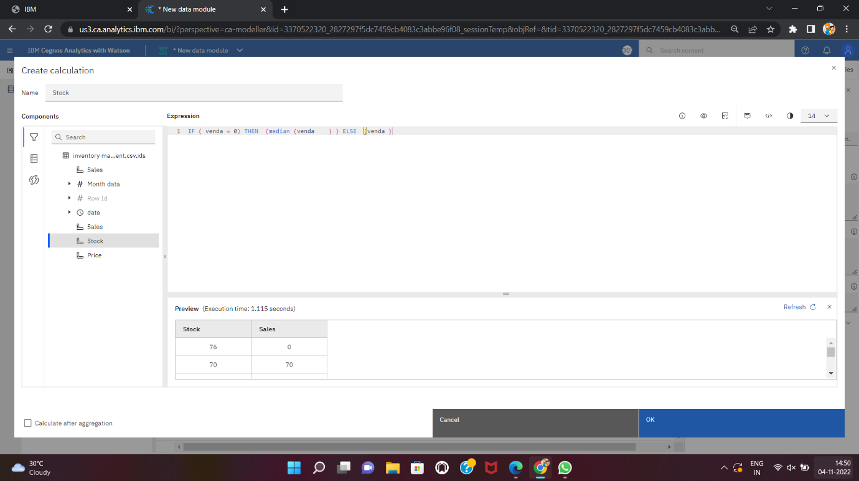

SALES:

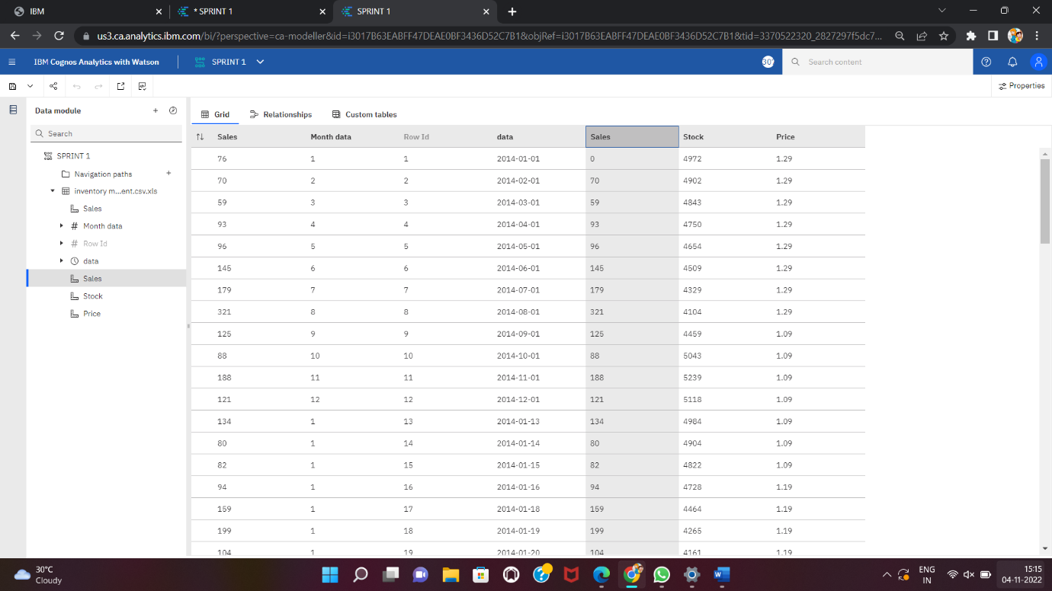

STOCK:

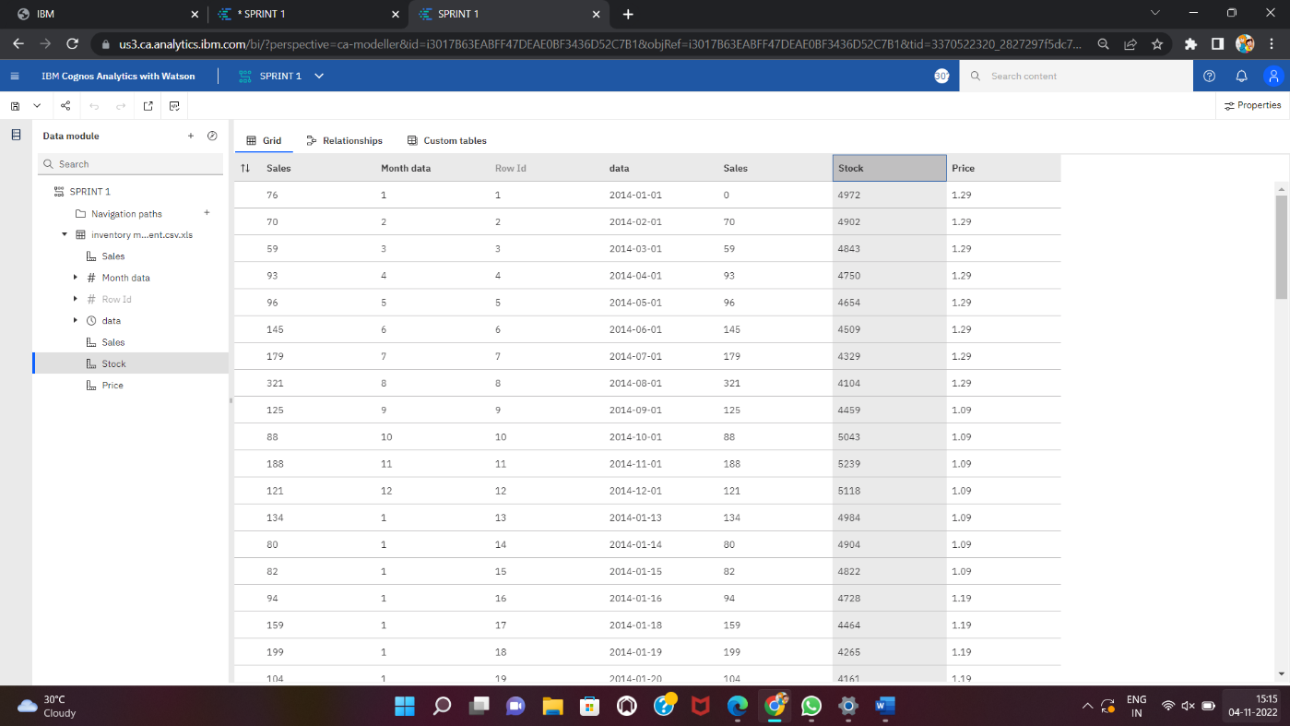

PRICE:

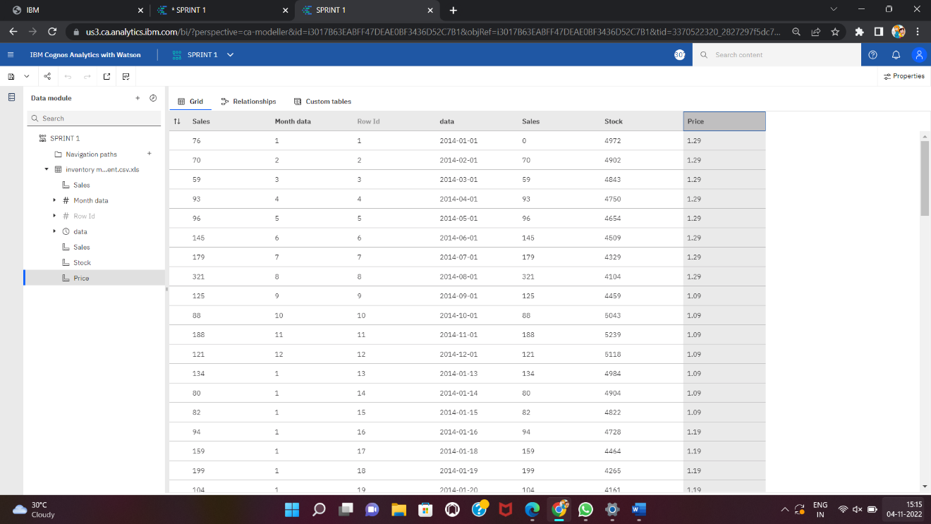

STOCK FORMAT DATA:

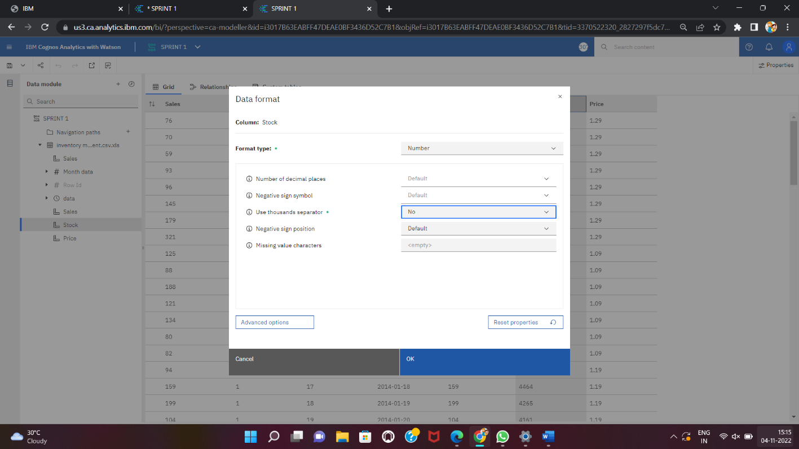

SALES FORMAT DATA:

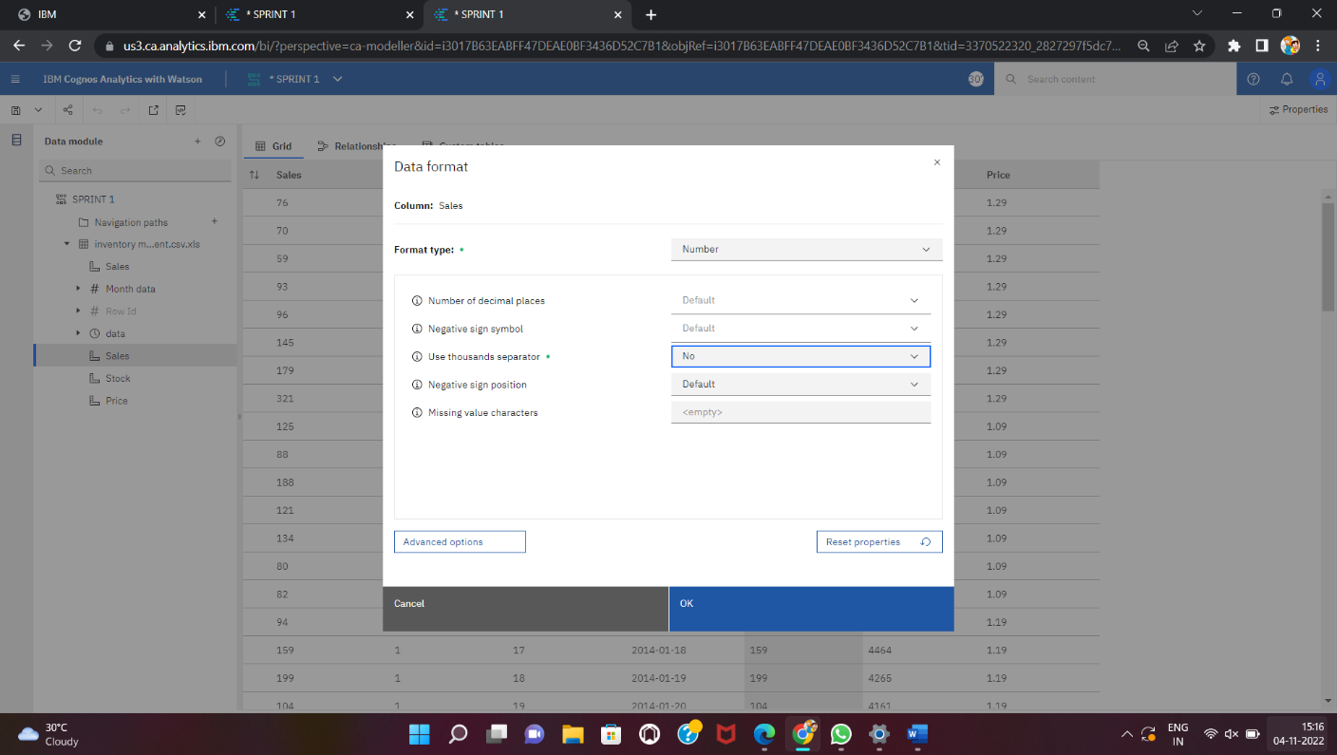

PRICE FORMAT DATA:

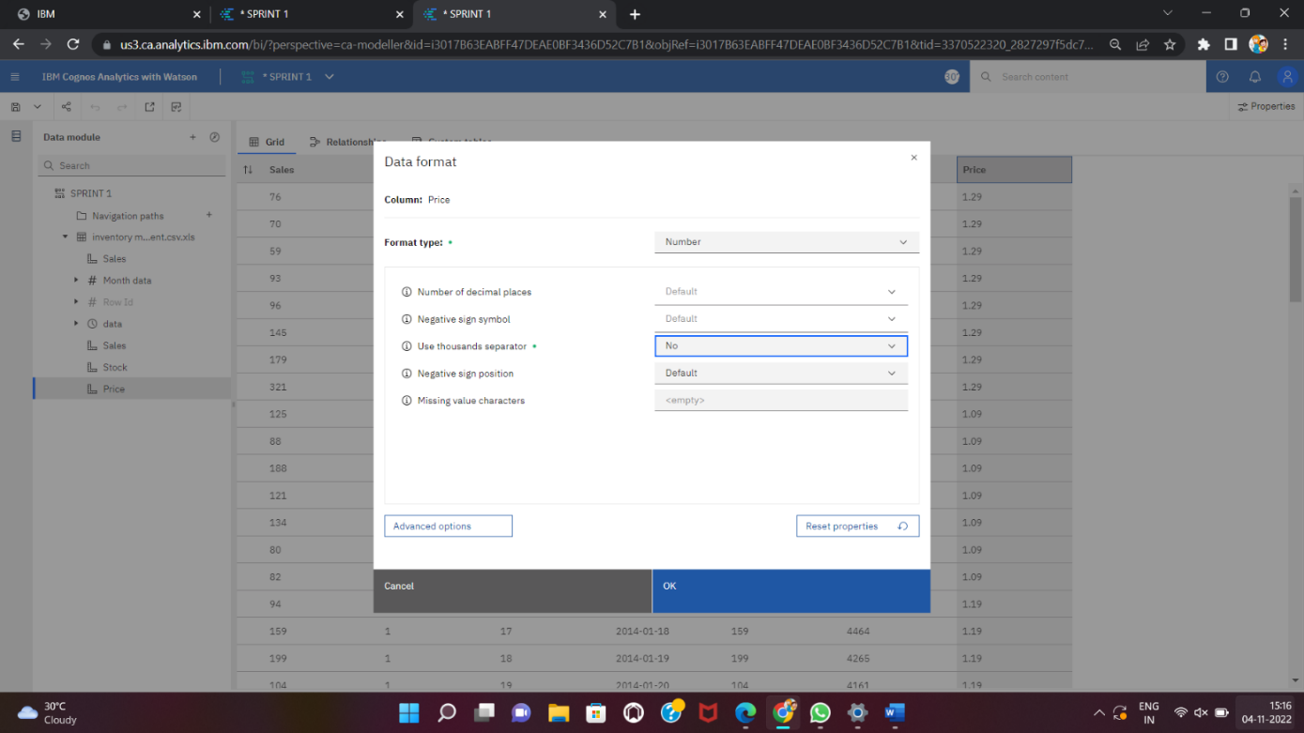

PREPARED DATASET LINK:

<https://us3.ca.analytics.ibm.com/bi/?perspective=ca-modeller&id=i3017B63EABFF47DEAE0BF3436D52C7B1&objRef=i3017B63EABFF47DEAE0BF3436D52C7B1&tid=3370522320_2827297f5dc7459cb4083c3abbe96f08_sessionTemp>